**Practical no: 7**

**AIM: Client server communication using socket programming.**

**Commands:**

**1) Generates private key.** 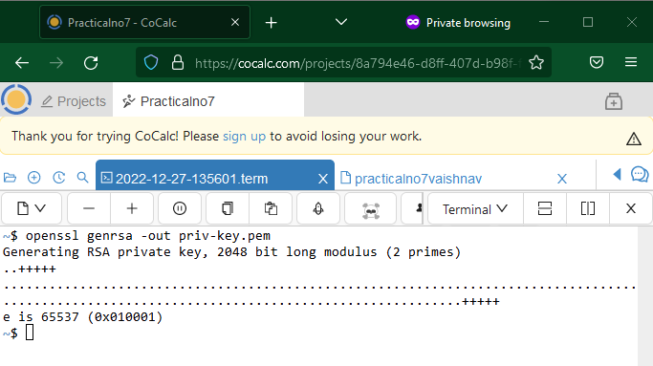

**2) Extracting public key.**

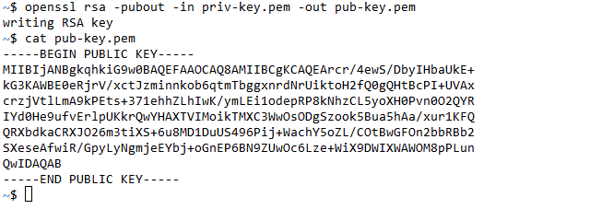

**3) Creating text files.**  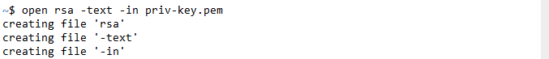

**4) Creating a message for encryption and decryption.**

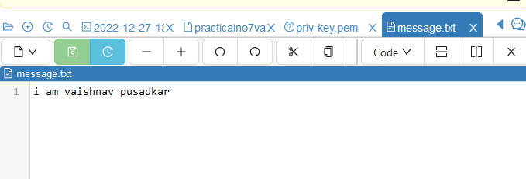

**5) Encryption of Message and reading it.**

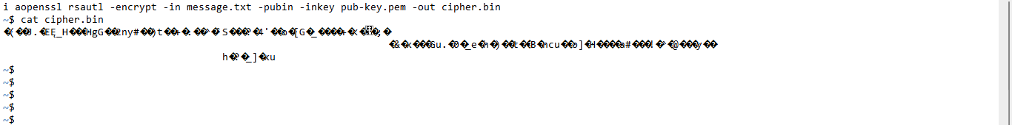

**6) , 7) Decryption and reading of decrypted message.**



**Conclusion: The mechanism behind RSA algorithm was implemented successfully.**